**Retail Sales Data Forecasting Models**

Alexander Van Roijen, Ashley Batchelor

**Introduction**

We created models to forecast sales for 12 weeks (~3 months) into the future. The models included total sales, and sales for the top five selling categories, based on average annual sales. The top five categories included Tomatoes, Potatoes, Apples, Citrus, and “Other Vegies.” We aggregated total sales for each category (or the grand total sales) over weekly periods.

Seasonal decomposition of each of the sales data sets showed that the total sales and the sales for each category showed a downward trendline. Sales are declining. The was a distinct annual seasonal component, which we approximated as 52 weeks.

We used the auto_arima feature from the Python statsmodels library to determine the best parameters for an ARIMA type of forecasting model. We used the last year of data as test data and the remainder as training data. We determined the best model was a SARIMA(0,1,1)x(1,0,1,52). We created one exogenous feature using Australian national holidays by labelling a count of the number of holidays in a week. This gave an improvement in each model. For example, our total sales had a RMSE value of 1551.00 without the exogenous variable, which improved to 1473.68 with the exogenous variable. Our final model was then a SARIMAX(0,1,1)x(1,0,1,52) with holidays as an exogenous factor.

All of the code for the models are in the github repository below.

<https://github.com/aibatchelor22/dubstech-2020>

**Forecasts**

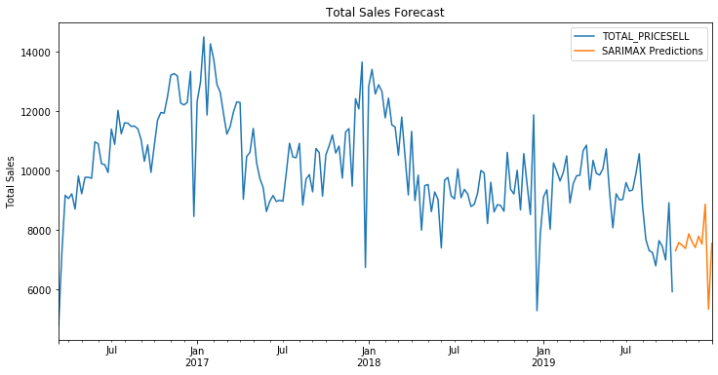

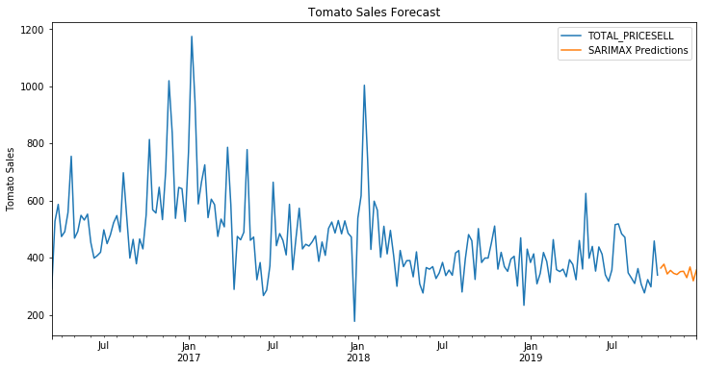

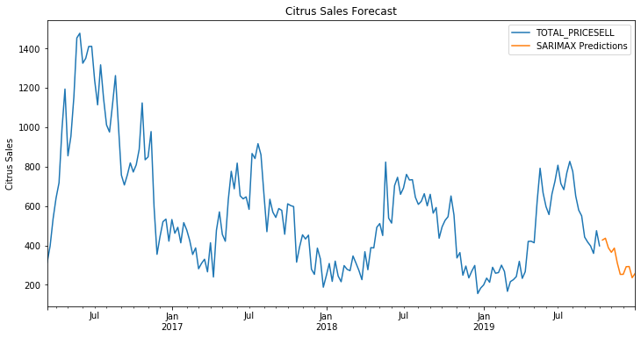

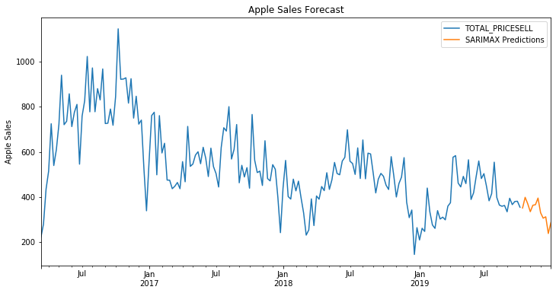

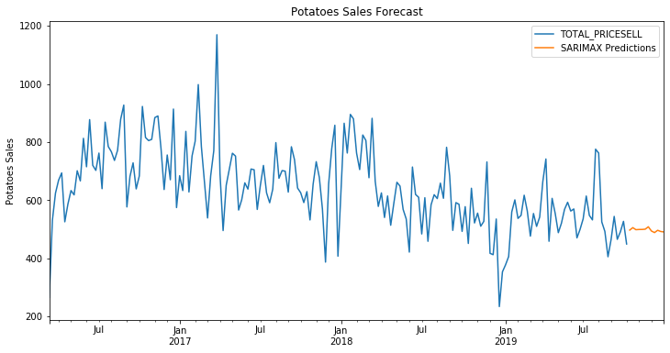

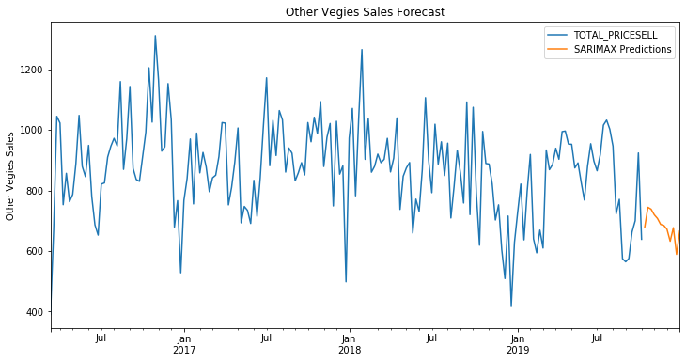

**Validation Summary**

Total Sales SARIMAX RMSE: 1473.677226

Tomatoes SARIMAX RMSE: 81.07202963

Citrus SARIMAX RMSE: 148.9479082

Apples SARIMAX RMSE: 165.0971303

Potatoes SARIMAX RMSE: 115.6674342

Other Vegies SARIMAX RMSE: 178.2398837

**Trend Data**

Total Sales

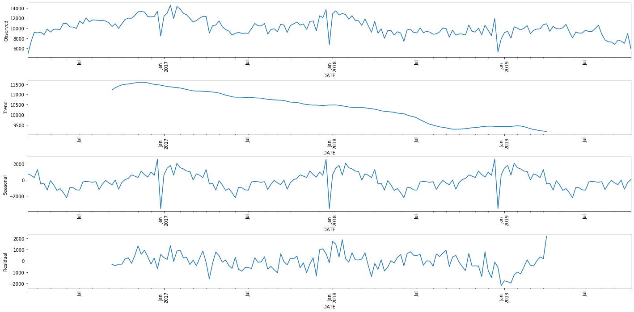

Tomatoes

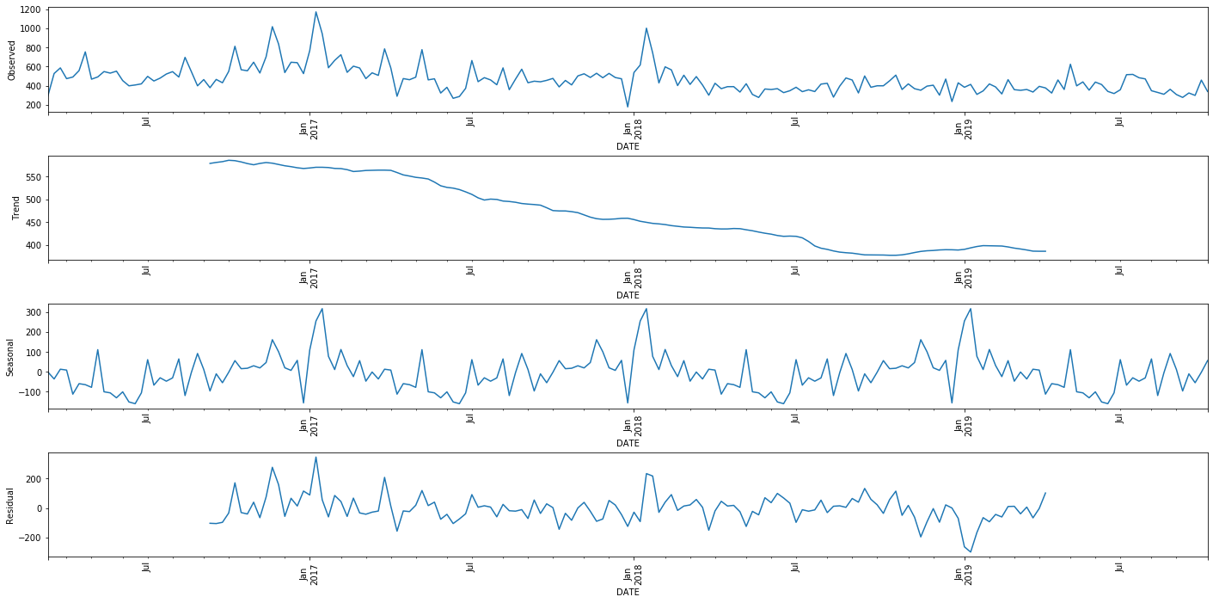

Citrus

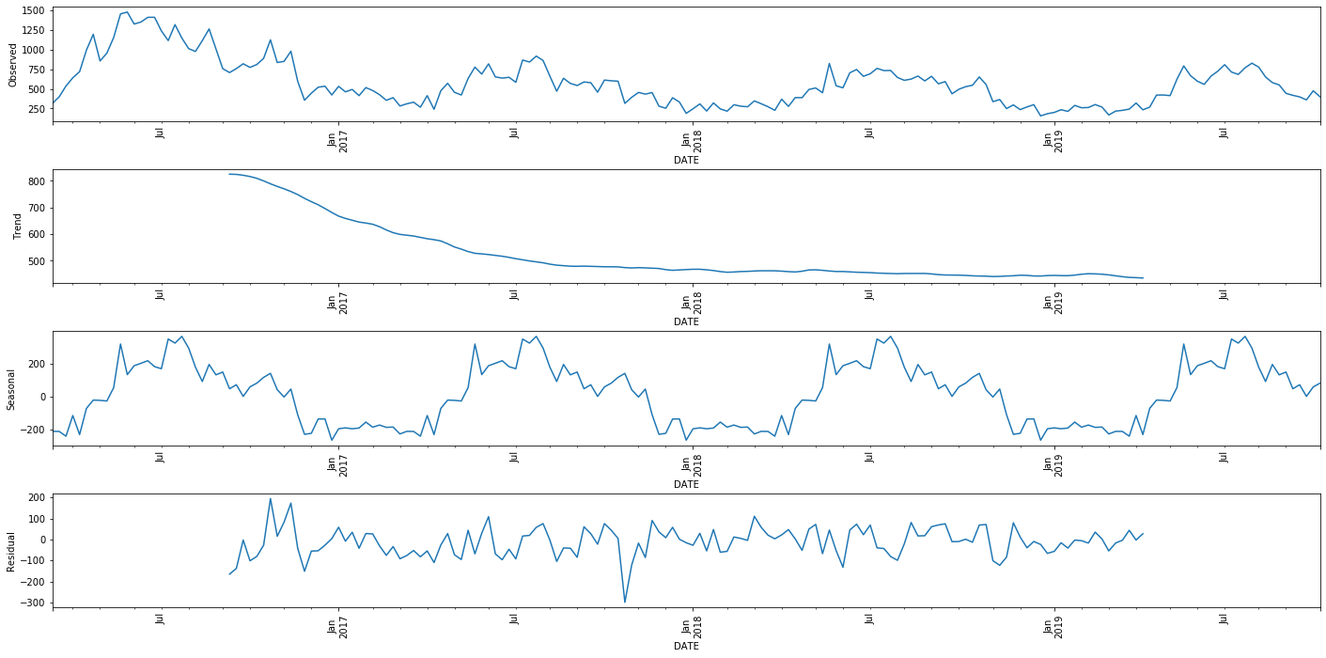

Apples

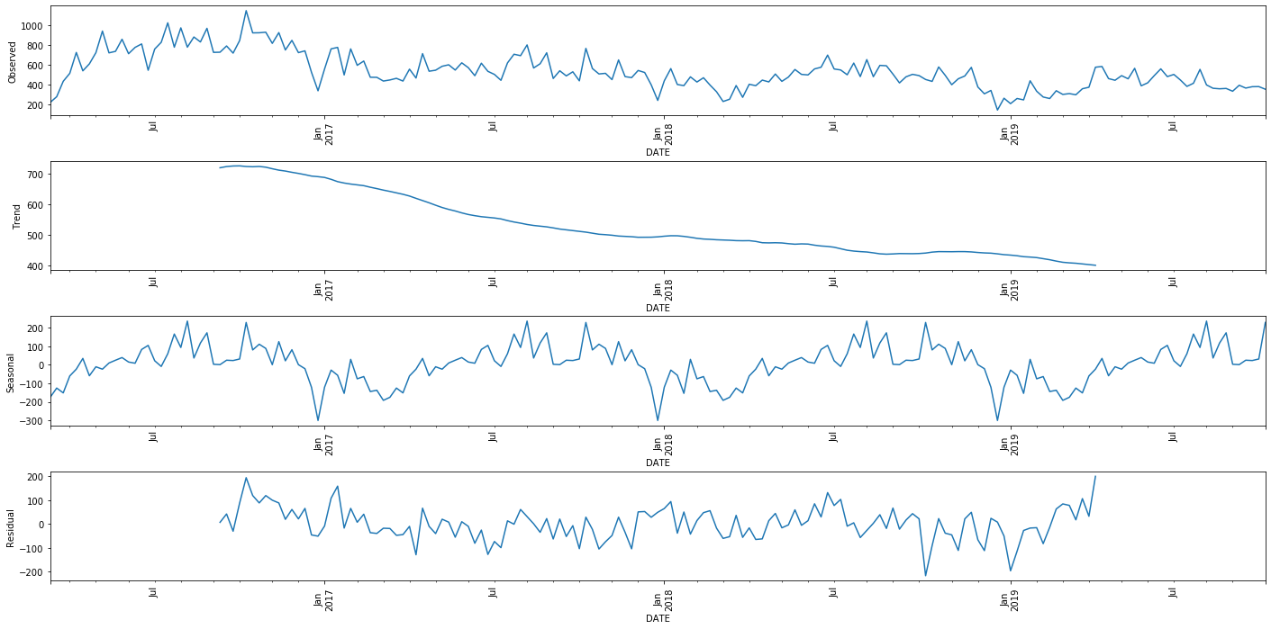

Potatoes

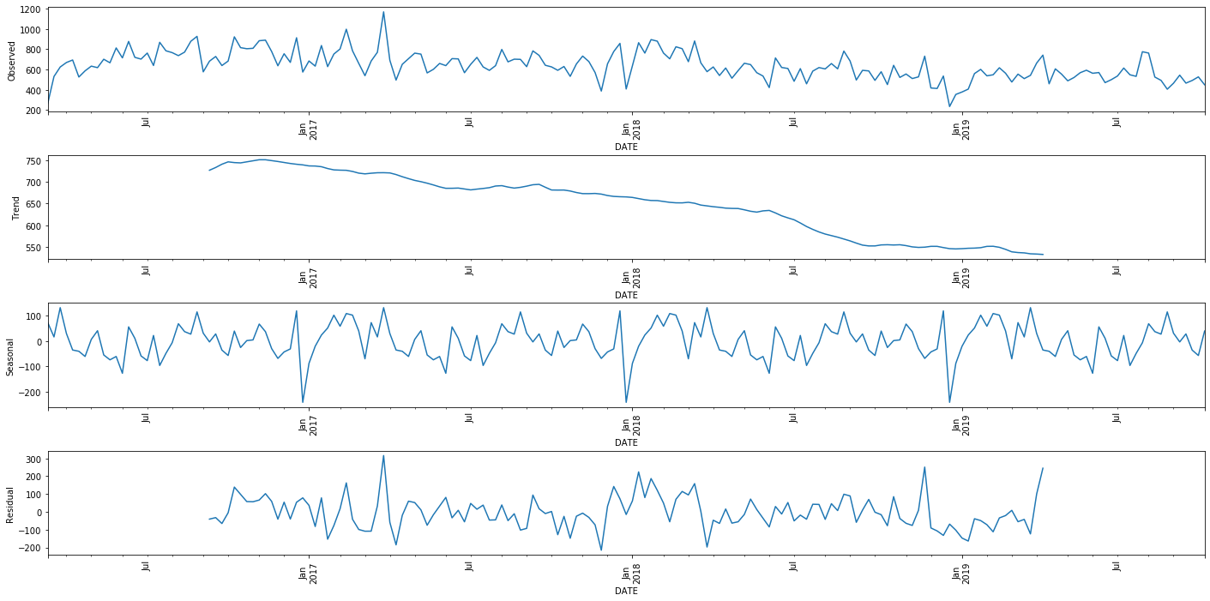

Other Vegies

